B. P. Mandal College of Engineering, Madhepura

Course: Bachelor of Technology

A Project Report On
Design and Development of 3D Product Advertisement of Noise Wireless Earbuds Using Blender

Submitted By
Student Name: KETAN ANAND
Registration No: 22118128007
Roll No: 22611
Branch: 3D Animation and Graphic Design
Semester (Year): 7th sem (4th year) Session: 2022–2026
Under the Guidance of
Prof. Md. Hafeezullah
BPMCE 2022–2026

Declaration


We hereby declare that the project report entitled
“Design and Development of 3D Product Advertisement of Noise Wireless Earbuds Using Blender”
submitted in partial fulfillment of the requirements for the award of the degree of B.Tech in the subject 3D Animation and Rendering is a record of original work carried out by us during the academic session 2025–26.
We further declare that:
- This project work has not been submitted previously to any other university or institution for the award of any degree or diploma.
- The work presented in this report is based on our practical implementation and learning using Blender software.
- All references and external sources used during the development of this project have been properly acknowledged.
- The project has been completed under the guidance and supervision of our faculty mentor.
We take full responsibility for the authenticity and originality of the work presented in this report.

Team Members:
NAME
REG. NO/ ROLL NO.
SIGNATURE

Project Guide:
Name: __________________________
Signature: ________________________

Date: __________________
Place: __________________

Acknowledgement
We would like to express our sincere gratitude to our respected project guide and faculty members for their continuous guidance, encouragement, and valuable suggestions throughout the development of this project titled
“Design and Development of 3D Product Advertisement of Noise Wireless Earbuds Using Blender.”
Their expert supervision helped us understand the complete 3D production pipeline, including modeling, shading, lighting, rendering, and post-processing techniques. Without their constant support and motivation, the successful completion of this project would not have been possible.
We are also thankful to our department for providing the necessary resources and learning environment required to carry out this project effectively.
We would like to acknowledge the open-source Blender community and online educational resources that helped us improve our practical understanding of 3D product animation techniques.
Finally, we express our heartfelt gratitude to our friends and classmates for their support, cooperation, and constructive feedback during the development of this project.
This project has greatly enhanced our technical knowledge, teamwork skills, and practical exposure to industry-level 3D animation workflows.

KETAN ANAND
Registration No: 22118128007

Certificate

This is to certify that Mr. KETAN ANAND, a student of the Department of 3D Animation and Graphics, B. P. Mandal College of Engineering, Madhepura, has successfully completed his Minor Project titled “Design and Development of 3D Product Advertisement of Noise Wireless Earbuds Using Blender.” as part of the curriculum for the 7th semester of the B.Tech program. The project was supervised by Prof. Md. Hafeezullah, and this report presents the work and findings during the project. The work has been completed by the student under my guidance, and the report is a true reflection of the work undertaken by him.

Mentor’s Signature:
Prof. Md. Hafeezullah
Mentor

Head of Department’s Signature:
Prof. Murlidhar Prasad Singh
HoD, CSE

Project Report

Introduction
In the modern digital era, product advertising has significantly evolved from traditional photography to computer-generated 3D visualization. Brands increasingly use 3D animation to present their products in a visually attractive and realistic manner. This project focuses on the creation of a professional-quality 3D advertisement of Noise Wireless Earbuds using Blender software.
The project was developed by a team of three members, where each member was assigned specific roles according to the 3D production pipeline. The entire workflow includes modeling, shading, texturing, lighting, animation, rendering, and post-processing.
The objective of this project was not only to create a visually appealing advertisement but also to understand and implement the complete 3D production pipeline used in professional studios.

PROJECT TEAM STRUCTURE AND
WORK DISTRIBUTION
Team Members
- Member 1 –
Modeling & Asset Creation Lead
- Member 2 –
Shading, Texturing & Lighting Artist
- Member 3 –
Animation, Rendering & Post-Processing Artist

WORK DIVISION OVERVIEW
The project pipeline was divided into three main departments:
Modeling Department
Responsible for creating accurate 3D geometry.
Look Development Department
Responsible for materials, textures, and lighting.
Rendering & Post-Production Department
Responsible for animation, final rendering, and compositing.
This division ensured smooth workflow and efficient collaboration.

Objectives
The primary objective of this project titled
“Design and Development of a 3D Product Advertisement of Noise Wireless Earbuds Using Blender”
is to understand and implement the complete 3D production pipeline used in professional product visualization and advertising industries. The project aims to combine creativity with technical knowledge to produce a high-quality commercial-style advertisement using Blender software.
The specific objectives of this project are as follows:
1. To Understand the Complete 3D Production Pipeline
  - The project aims to gain practical knowledge of the full 3D workflow, including:
  - 3D Modeling
  - Shading and Texturing
  - Lighting Setup
  - Camera Animation
  - Rendering
  - Compositing and Post-Processing
  - Understanding this pipeline helps simulate real-world industry production methods.
2. To Develop Accurate 3D Modeling Skills
  - Create a detailed and proportionally accurate 3D model of wireless earbuds and charging case.
  - Apply proper topology techniques for smooth surfaces.
  - Use modifiers efficiently for professional-quality geometry.
3. To Apply Physically Based Rendering (PBR) Principles
  - Learn how real-world materials interact with light.
  - Create realistic plastic and metallic materials using the Principled BSDF shader.
  - Control roughness, specular highlights, and reflections for product realism.
4. To Design Professional Studio Lighting
  - Implement a three-point lighting system (Key, Fill, Rim light).
  - Use HDRI environment lighting for realistic reflections.
  - Understand the importance of light intensity, direction, and softness in product visualization.
5. To Create Cinematic Camera Animation
  - Plan and execute smooth camera movements such as orbit, dolly-in, and reveal shots.
  - Use keyframes and graph editor to refine animation curves.
  - Apply depth of field to achieve cinematic focus effects.
6. To Perform High-Quality Rendering
  - Use Cycles render engine for physically accurate results.
  - Optimize render settings for balance between quality and performance.
  - Reduce noise using denoising techniques.
7. To Apply Post-Processing Techniques
  - Use Blender compositor for color correction and contrast adjustment.
  - Enhance visuals using glare and exposure control.
  - Export final advertisement in high-definition video format.
8. To Enhance Team Collaboration Skills
  - Divide work efficiently among three team members.
  - Maintain organized workflow and communication.
  - Simulate real-world production teamwork environment.
9. To Gain Industry-Relevant Experience
  - Understand how 3D advertisements are created professionally.
  - Build practical experience useful for careers in 3D animation, product visualization, and digital marketing industries.
10. To Improve Technical and Creative Skills
  - Strengthen problem-solving abilities.
  - Improve creativity in product presentation.
  - Gain confidence in handling complete 3D projects independently.

Scope of the Project
The scope of this project titled
“Design and Development of a 3D Product Advertisement of Noise Wireless Earbuds Using Blender”
covers the complete digital production workflow required to create a professional-quality 3D product advertisement. The project focuses on implementing industry-standard 3D animation techniques using Blender software and demonstrates practical application of modeling, shading, lighting, animation, rendering, and post-processing.
1. Technical Scope
The technical scope of this project includes the following components:
1.1 3D Modeling
- Creation of detailed and accurate 3D models of wireless earbuds and charging case.
- Application of proper topology and mesh optimization techniques.
- Use of modifiers such as Subdivision Surface, Bevel, and Mirror.
This ensures that the product geometry is smooth and suitable for high-quality rendering.
1.2 Shading and Texturing
- Implementation of Physically Based Rendering (PBR) principles.
- Creation of realistic plastic and metallic materials.
- Adjustment of surface properties such as roughness, specular, and metallic values.
This stage enhances realism and improves visual appeal.
1.3 Lighting Setup
- Designing a professional studio lighting environment.
- Application of three-point lighting system.
- Use of HDRI for realistic reflections and ambient illumination.
Lighting plays a major role in highlighting product features and surface quality.
1.4 Camera Animation
- Creation of cinematic camera movements such as orbit and dolly shots.
- Use of keyframes and graph editor for smooth motion.
- Application of depth of field for professional visual presentation.
This ensures that the advertisement appears dynamic and engaging.
1.5 Rendering
- Use of Cycles render engine for photorealistic output.
- Optimization of render samples and denoising.
- High-definition video output (Full HD).
Rendering converts the 3D scene into final visual output.
1.6 Compositing and Post-Processing
- Color correction and exposure adjustment.
- Addition of glare effects and contrast enhancement.
- Final export in video format suitable for advertisement.
Post-processing enhances the commercial look of the advertisement.
2. Educational Scope
This project provides practical learning in:
- Real-world 3D production pipeline
- Industry-standard product visualization workflow
- Team-based project management
- Problem-solving in rendering and animation
It bridges the gap between academic theory and industry practice.
3. Industry Scope
The techniques used in this project are widely applied in:
- E-commerce product advertisements
- Social media marketing campaigns
- Digital product launches
- Television and online commercials
- Brand promotion videos
3D product visualization is increasingly replacing traditional photography due to flexibility, cost efficiency, and creative control.
4. Future Scope
The project can be further enhanced by:
- Adding motion graphics and typography
- Incorporating sound design and background music
- Creating multiple product color variations
- Developing real-time versions using game engines
- Expanding into Augmented Reality (AR) product visualization
5. Limitations of the Project
While the project demonstrates a complete 3D workflow, it is limited to:
- A single product model
- Pre-rendered animation (not real-time)
- Basic compositing within Blender
Advanced simulation effects and large-scale production techniques were beyond the current scope.

MEMBER 1 – MODELING & ASSET CREATION
Role and Responsibilities
Member 1 was responsible for:
- Reference collection
- Base mesh modeling
- High-detail modeling
- Topology refinement
- Modifier management
- Scene asset organization
Reference Study and Planning
Before modeling, detailed product references were collected. These references helped in understanding:
- Product proportions
- Surface curvature
- Edge smoothness
- Button placement
- Case opening mechanism
Base Modeling Process
Modeling began using primitive objects:
- Cylinder for earbud stem
- Sphere for curved cap
- Cube for charging case
Edit Mode was used to manipulate vertices and edges.
Subdivision Surface modifier was applied to smooth the geometry.
Bevel modifier was used to soften sharp edges.
Mirror modifier ensured symmetrical modeling.

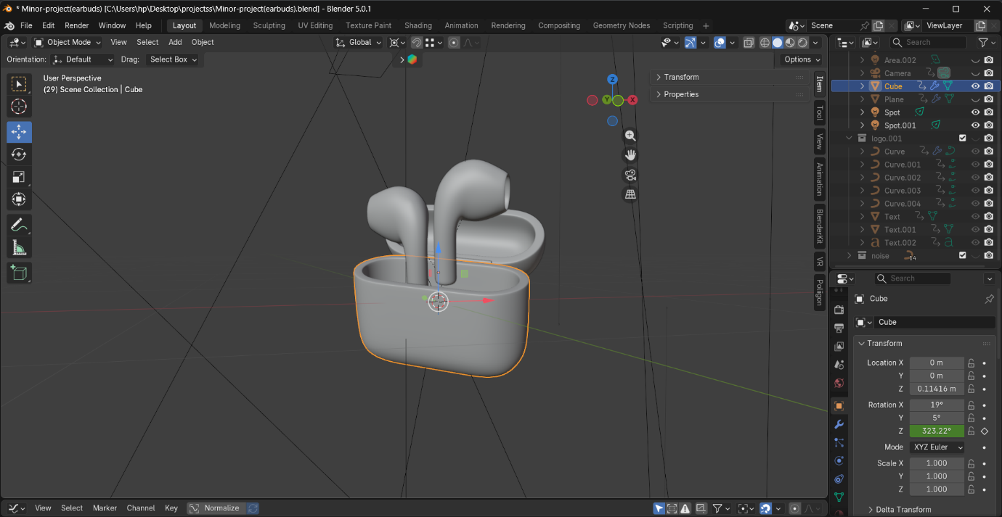
Fig.1
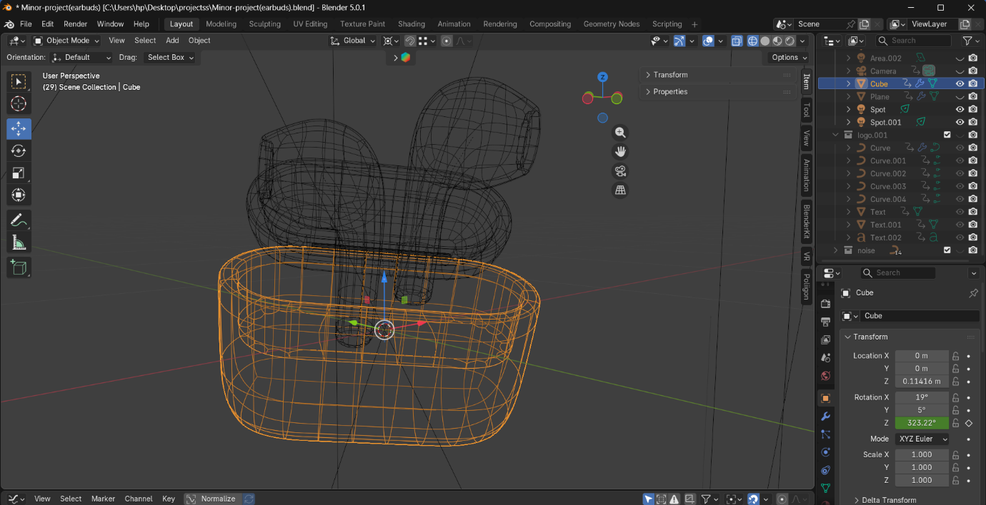
Fig. 2
Topology Management
Clean topology was maintained to ensure:
- Smooth shading
- Accurate reflections
- No rendering artifacts
Edge loops were strategically placed to control curvature.
Proper topology is essential in product visualization because reflections reveal surface imperfections.
Final Model Output
The final 3D model consisted of:
- Two earbuds
- Charging case
- Lid mechanism
- Internal detailing
All parts were properly named and organized in the outliner panel.
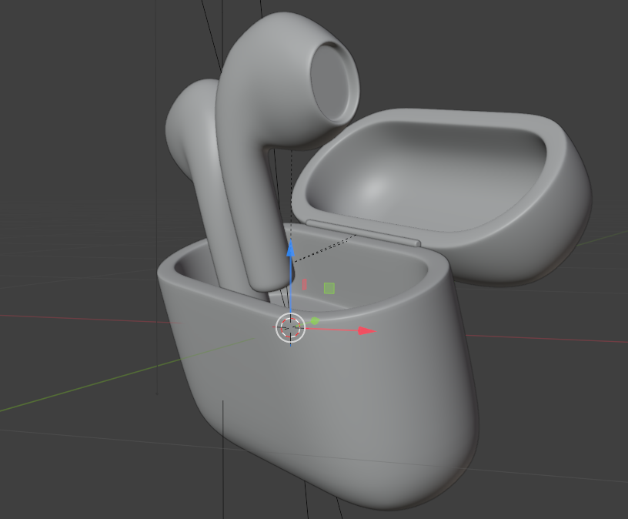

MEMBER 2 – SHADING, TEXTURING & LIGHTING
Role and Responsibilities
Member 2 handled:
- Material creation
- Shader node setup
- Texture adjustments
- Reflection control
- Studio lighting setup
- HDRI environment setup
Physically Based Rendering (PBR)
The project used Physically Based Rendering principles.
PBR ensures that materials react realistically to light.
Key properties used:
- Base Color
- Roughness
- Metallic
- Specular
- Normal mapping
Material Creation
The Principled BSDF shader was used.

Plastic material setup:
- Low roughness
- Slight specular highlight
Metallic ring setup:
- Metallic value near 1
- Controlled roughness for reflection sharpness
Case interior:
- Matte plastic finish
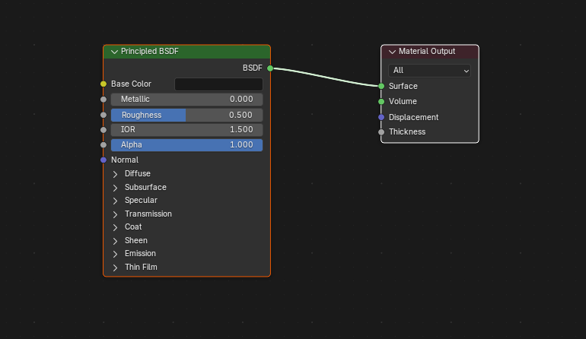
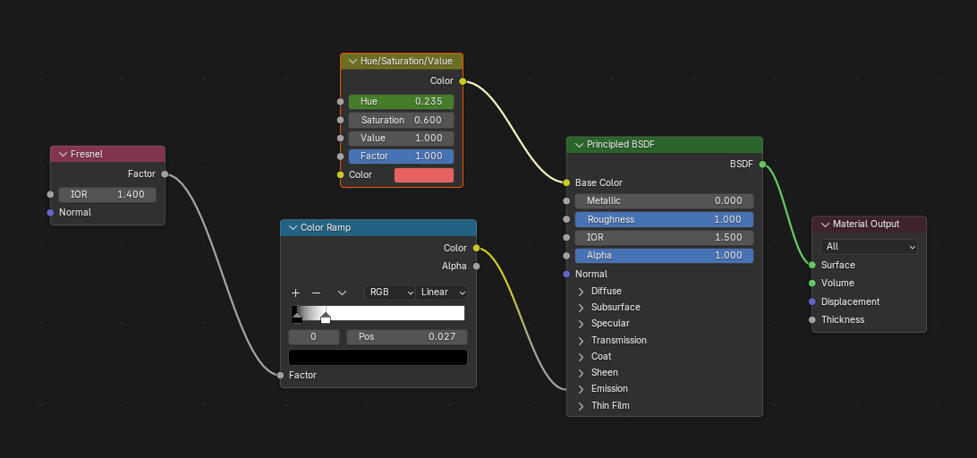
Reflection and Surface Realism
Reflection is critical in product ads.
Small adjustments in roughness dramatically changed the realism.
Careful balancing ensured:
- No over-shiny plastic
- No dull surface
Lighting Design
Lighting setup followed professional studio techniques.
Three-point lighting system:
- Key Light – Main light source
- Fill Light – Softens shadows
- Rim Light – Highlights edges
HDRI was used for natural ambient reflections.
Lighting helped in defining:
- Product shape
- Surface texture
- Depth and contrast
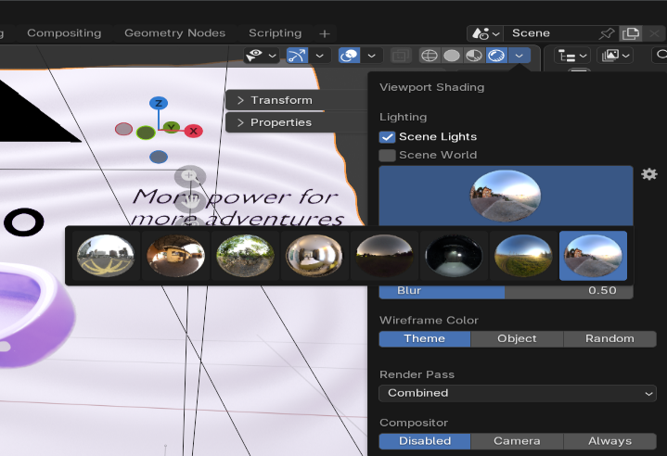
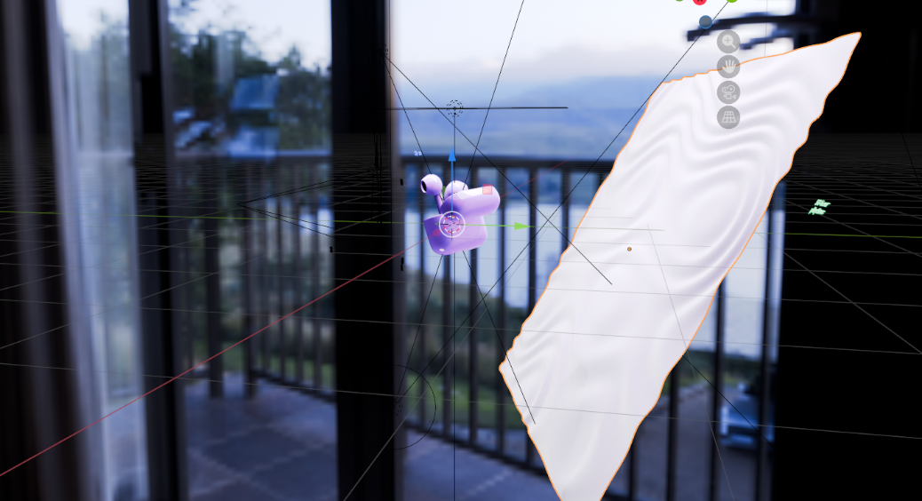
MEMBER 3 – ANIMATION, RENDERING & POST-PROCESSING
Role and Responsibilities
Member 3 was responsible for:
- Camera setup
- Keyframe animation
- Graph editor smoothing
- Render configuration
- Compositing
- Final export
Camera Animation
Professional product advertisements use cinematic camera movements.
Techniques used:
- Orbit rotation around product
- Slow dolly-in movement
- Close-up reveal
- Depth of Field for focus
Keyframes were added in timeline.
Graph Editor was used to smooth animation curves.
Rendering Process
Render Engine: Cycles
Cycles uses ray tracing to simulate realistic light behavior.
Render settings:
- Resolution: 1920 × 1080
- Frame rate: 24 fps
- Samples: 1000+
- Denoising enabled
Higher samples reduced noise but increased render time.
Noise Reduction
Noise is common in ray-traced rendering.
Solutions used:
- Increased samples
- Enabled denoiser
- Optimized light strength
Compositing and Post-Processing
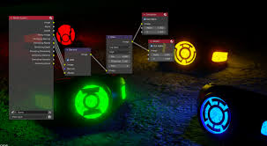
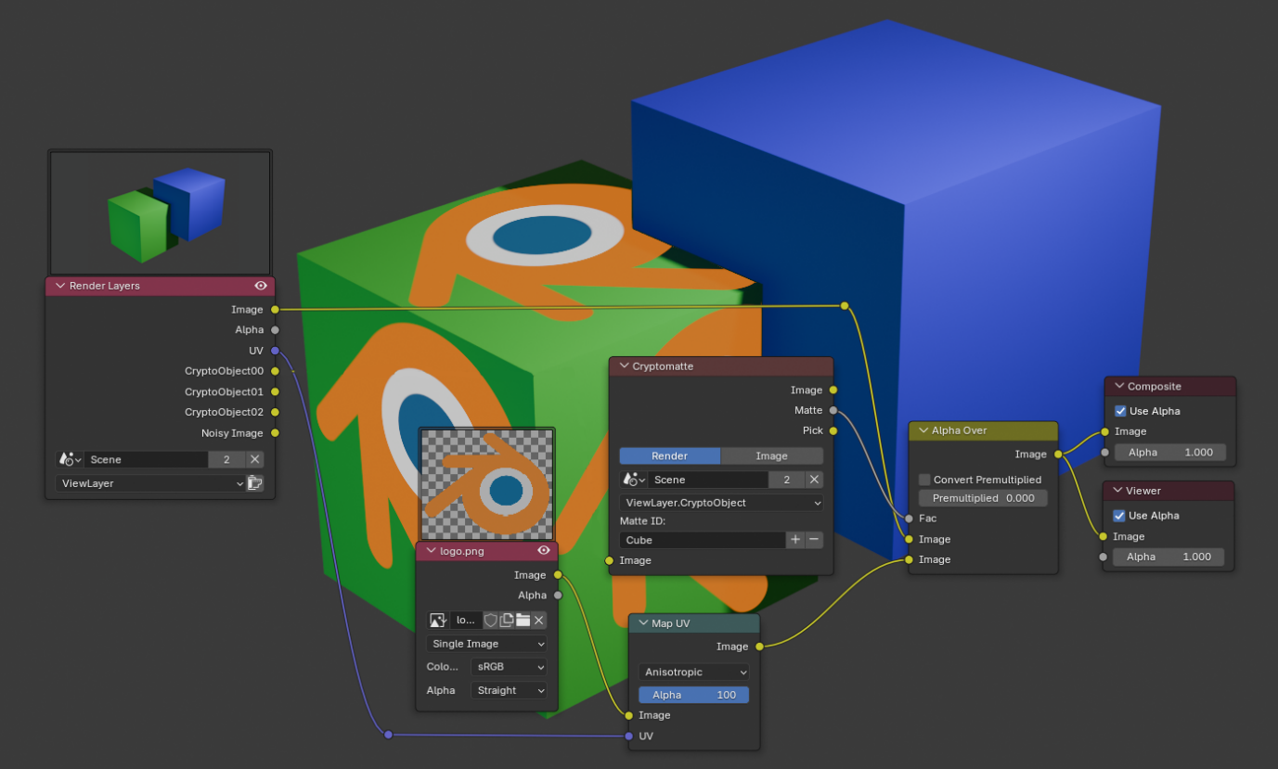
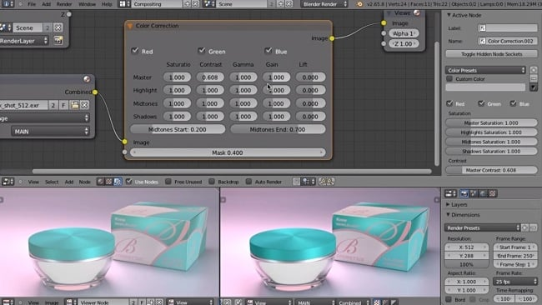

Compositor nodes were used for:
- Color correction
- Contrast adjustment
- Glare effect
- Exposure balancing
Post-processing enhanced commercial appearance.
Final output exported as MP4 video.

Conclusion
My internship at Aagaaz Training Centre Pvt. Ltd. provided me with a solid foundation in the field of 3D Modeling, particularly using Blender. Over the span of four weeks, I developed technical skills that included:
- Navigating and using Blender’s interface effectively
- Modeling basic and intermediate 3D objects like a dustbin and chair
- Applying textures and using UV mapping techniques
- Using lighting, rendering settings, and camera positioning
- Exporting and presenting my final 3D work in a professional format
This internship was not only beneficial in terms of technical learning, but also helped me grow in time management, problem-solving, and digital presentation skills. The mentorship provided by the organization helped me clarify many industry-standard workflows and improve my practical design thinking.
Completing the final 3D dustbin and chair models gave me immense confidence in my creative capabilities and motivated me to further explore this field in depth.
I am thankful to my college, B.P. Mandal College of Engineering, Madhepura, and to
Aagaaz Training Centre Pvt. Ltd. for giving me the opportunity and environment to grow professionally.

Learning Outcomes
The internship at Aagaaz Training Centre Pvt. Ltd. helped me develop both technical expertise and professional skills in 3D modeling. Through structured weekly tasks and a final project, I was able to strengthen my foundation in digital design.
Technical Skills Gained
- Proficiency in Blender: Navigated UI, used shortcuts, customized workspace.
- 3D Modeling Techniques: Used primitive shapes, modifiers, Boolean ops, and loop cuts.
- UV Unwrapping and Texturing: Assigned UV maps, applied shaders, and used Blender’s node editor.
- Lighting & Rendering: Worked with lights, render engines (Eevee/Cycles), and camera setups.
- Workflow Planning & Organization: Followed layer-based and structured modeling pipelines.
Soft Skills Developed
- _{Time Management:} Allocated learning, practice, and execution hours efficiently.
- _{Problem Solving:} Resolved modeling issues like texture stretching and geometry errors.
- Creativity & Detailing: Gave realistic design and form to objects like a dustbin.
- Professional Presentation: Learned to document, organize, and present work effectively.
This experience bridged theory with real-world application and has prepared me for future roles in animation, gaming, and digital media design.

Acknowledgement
I would like to express my deepest gratitude to Aagaaz Training Centre Pvt. Ltd. for giving me the opportunity to undertake this enriching internship in the field of 3D Modeling. The practical exposure and insights I gained have been immensely valuable in shaping my technical understanding and professional growth.
My heartfelt thanks to the entire team of trainers and mentors at Aagaaz who were always supportive, patient, and generous in sharing their expertise throughout the internship.
I am especially thankful to my college, B.P. Mandal College of Engineering, Madhepura, and the Department of 3D Animation and Graphics, for encouraging me to pursue this internship and supporting me with the necessary guidance.
Last but not the least, I would also like to thank my family and friends for their constant encouragement and motivation.
This internship experience will undoubtedly serve as a strong foundation for my future career in the animation and graphics industry.

References
- Blender Official Documentation https://docs.blender.org
Used for understanding Blender tools, modifiers, and rendering workflows.
- YouTube Tutorials
  - Blender Guru – Beginner Donut Series
https://www.youtube.com/user/AndrewPPrice
  - Ducky 3D Tutorials
https://www.youtube.com/c/Ducky3D
- CG Cookie – Learning Platform
https://cgcookie.com/
Helpful in learning modeling and workflow techniques.
- Books
  - Blender 3D: Noob to Pro – WikiBook
  - Learning Blender: A Hands-On Guide to Creating 3D Animated Characters by Oliver Villar
- Other Tools Used
  - Substance Painter (basic exposure to texturing)
  - Maya and Arnold Renderer (for understanding rendering concepts)

